Automobilista 2 supports the VNM Direct Drive Firmware controller device out-of-the-box as a Custom wheel.

Configuration is straight-forward and can be done in game in the Options menu.

1. Go into Options > Controls. In the *Control Scheme* tab, select the *Type* section and choose “Wheel”
2. In the Make section, choose “Custom”
3. Set Pedal Type to “Separate”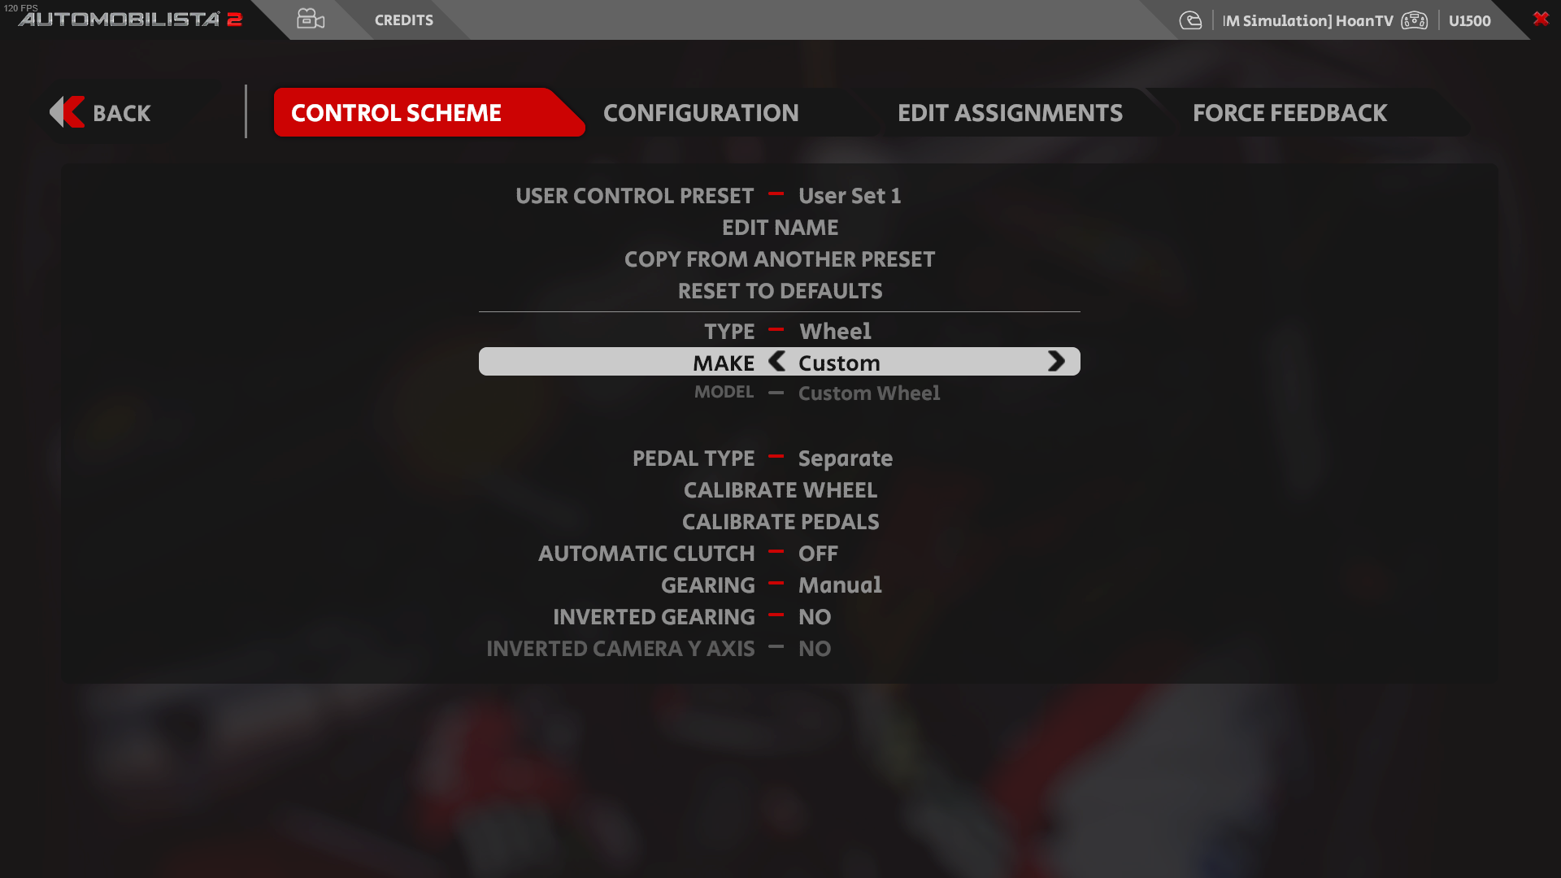
4. Go into *Edit Assignments.* Click on “Steer Left” and “Steer Right” to bind it to your wheels. Note that you need to turn the wheel to 50% and return to center for the game to recognise the input
5. Do the same for Throttle, Brake and Clutch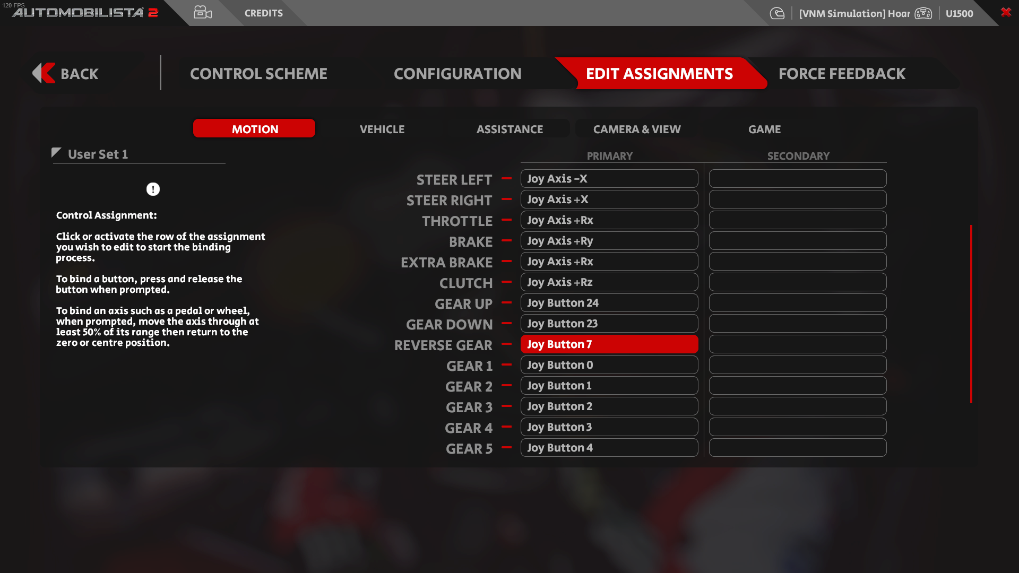
6. Go back into *Control Scheme*, choose “Calibrate Wheels” and follow the game instruction. Do the same for Pedals
7. Set the Force Feedback settings to your liking

Setting for Project Cars 2 are done the same